VAISHNAVI E 231901059
EXERCISE 12
Demonstrate Cyber Evasion Techniques

Aim: To learn various cyber evasion techniques and apply them to test the effectiveness of two Intrusion Detection Systems (IDS).
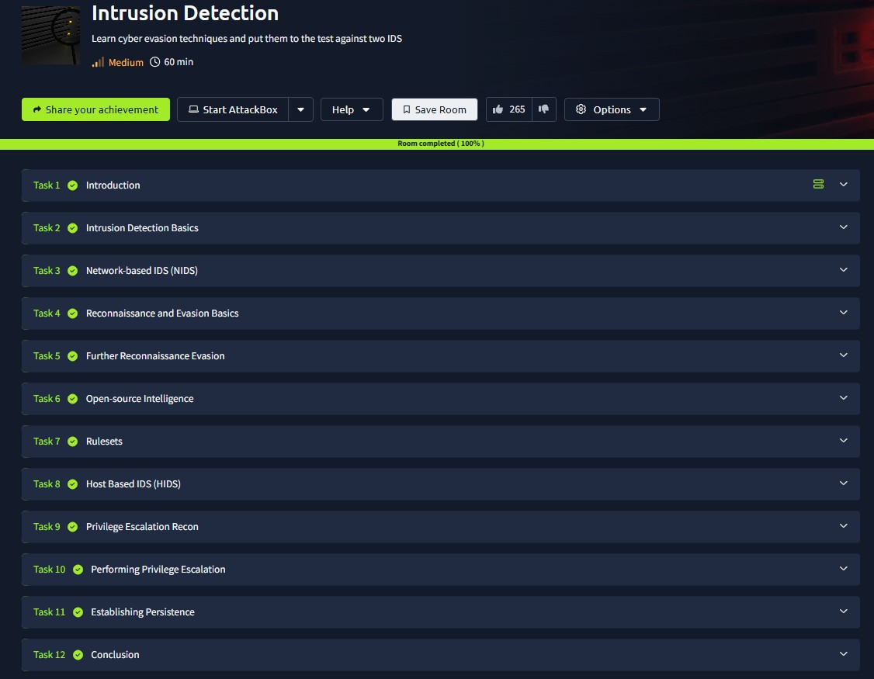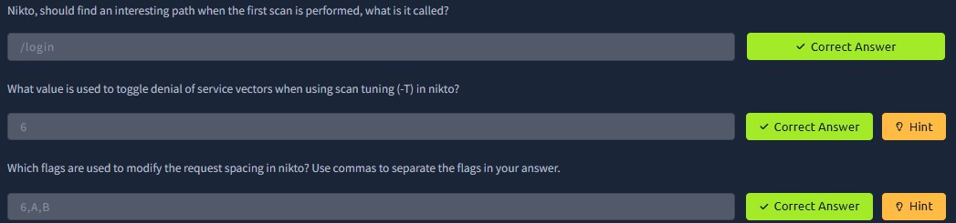
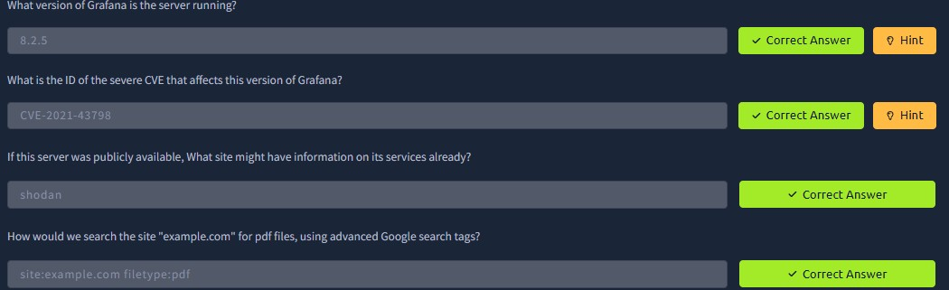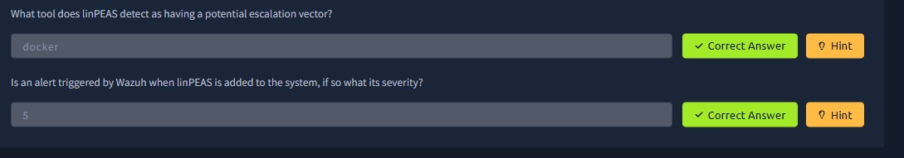
Result: Successfully executed multiple evasion techniques and evaluated their impact, identifying the strengths and weaknesses of both IDS setups against stealthy attack patterns.

